|  |  |
| --- | --- |
|  |  |
| **SUSTAINABLE WASTE** |  |
| **PROJECT PROCESS BOOK** |  |
| **COS30045 – DATA VISUALISATION** |  |
| **Website Link:** [**https://mercury.swin.edu.au/cos30045/s101964547/visualisation_project/global_msw.html**](https://mercury.swin.edu.au/cos30045/s101964547/visualisation_project/global_msw.html) |  |

**SUSTAINABLE WASTE**

**LA9_C3**

**RYAN WELLS   
SYED OMAIR MAQDOOM MOHIUDDIN**

**Monday 4:30 PM to 6:30 PM**

**2021 SEMESTER – 1**

**WORD COUNT: 5260  
Website LINK:** [**https://mercury.swin.edu.au/cos30045/s101964547/visualisation_project/global_msw.html**](https://mercury.swin.edu.au/cos30045/s101964547/visualisation_project/global_msw.html)

**1.Introduction** 5

1.1 Background and Motivation 5

1.2 Visualisation Purpose 5

1.2.1 Questions answered by visualisation 5

1.2.2 Possible benefits of completed visualisation 6

1.3 Key Terms 6

1.4 Project Schedule 7

**2.Data** 8

2.1 Data Source (Proposal) 8

2.1 Data Source (Final) 8

2.2 Data Processing (Proposal) 11

2.2 Data Processing (Progress) 11

2.2 Data Processing (Final) 12

**3.Requirements** 12

3.1 Must-Have features (Proposal) 13

3.1 Must-Have Features (Final) 13

3.2 Optional Features (Proposal) 14

3.2 Optional Features (Final) 14

3.3 Successfully Implemented features 15

**4. Visualisation Design** 15

4.1 Initial designs 15

4.2 High-fidelity prototyping 17

4.3 Choropleth map progress 17

4.4 Pie Chart Progress 20

4.5 Scatter Plot Progress 22

4.5 Finalising the Design 24

**5.Validation** 25

5.1 Informed Consent 25

5.2 Pre-Study Questionnaire 26

5.3 Evaluation Tasks 27

5.4 Post-Study Questionnaire – 1 29

5.5 Post-Study Questionnaire – 2 29

5.6 Responses and Results 30

5.6.1 User Observation 30

5.6.1.1 User – 1 31

5.6.1.2 User – 2 32

5.7 Required Changes 35

**6. Conclusion** 36

**References** 37

# **1.Introduction**

Dealing with large amounts of data when making decisions can be simplified by using data visualisation techniques. These techniques include a wide range of visual designs for effective communication of data, including charts and statistical plots. Bars, lines and dots are utilised for quantitative data such as numerical data to improve user engagement and help the user interpret the data effectively and efficiently. In day-to-day life we are connected with different visualisations, they can help us to achieve our required goals.

## 1.1 Background and Motivation

* People that are 16-30 years old who are interested in reducing the amount of waste that they are producing.

what we mean by waste - items that are sent to landfill by municipalities

* + - breakdown based on country
    - socioeconomic status of countries
    - different categories of waste

## 1.2 Visualisation Purpose

The purpose of this report is to show the iterative process followed when designing the website. It consists of all the essential information regarding the procedure followed from the beginning of the project, i.e., introducing the data to the end, finalised form of the website. We followed best practices in all the phases of the project.

### 1.2.1 Questions answered by visualisation

* how much waste different countries produce?
* how well different countries handle waste management?
* the amount of waste produced that could be better utilised.
* Compare GDP and the amount of waste generated country wise?
* Countries can compare the amount of waste they generate with other countries and try to take required steps to reduce the generated waste.
* Compare proportion of production of waste from various sectors (for instance, food and organic VS glass).
* Analyse, is there any relation between GDP and waste production.

### 1.2.2 Possible benefits of completed visualisation

* influence purchasing habits
* Influence living (consuming) habits
* Influence global policies relating to waste (waste is a global issue, not just for Australia/Victoria and developing nations may need assistance creating policy as they become more developed)
* Countries can follow policies/plans used by co-countries whose GDP is high and waste generation is low.
* Countries can tailor their policies according to the composition of their waste. For example, America has a high proportion of paper and cardboard entering landfill, so policies could be created to increase the amount of paper and cardboard being recycled.

## 1.3 Key Terms

* Visualisation: Graphical (interactive) representation of information. [Vonbaggo,K (2021)]
* Gross Domestic Product (GDP): The monetary or market value of all the final goods and services produced inside a country’s borders at a certain point in time. [Jason F, Michael B (2020)]
* Municipal Solid Waste (MSW): It is referred to trash/rubbish/garbage.
* Prototype: A sample or early version of an application or item from which later versions are created. [Virginia R (2018)]
* Alignment: Positioning text and other design components on a page in such a way that they are balanced. It aids in the creation of order, the organisation of elements, the creation of visual links and the readability of the design. [The Paper (2015)]
* Contrast: A distinction in a composition between various components of design. The bigger the contrast between the components, the easier it is to analyse and understand by the user. [UX Collective (2020)]
* Affordance: Clues that provide users an idea how they might engage with the components. [UX Planet (2018)]

## 1.4 Project Schedule

Table : Project Schedule table

|  |  |
| --- | --- |
| **Week** | **Work to be completed** |
| Week 1 | Planning for different visualisations and searching for dataset. Interacting with new group members and discussing ideas. |
| Week 2 | Searching for data related to the project topic (sustainability: Waste). Discussing about the gathered data and choosing the best data for the project. |
| Week 3 | Find example visualisations for inspiration and prepare sketches (prototyping). Start making report on the project (Process Book). |
| Week 4 | Prepare paper prototype and discussing views and gathering feedback from group. Updating process book. |
| Week 5 | Update the prototypes following feedback from tutor and adding some more designs to visualisations. Updating process book. |
| Week 6 | Use online tools to prepare high fidelity prototypes for the project. Start the programming visualisation. Distribute work among group members. Updating process book. |
| Week 7 | Continue programming and discuss any issues in group meetings. Updating the process book with information regarding the website (Visualisations). |
| Week 8 | Complete basic functionality of visualisations.  Updating process book. |
| Week 9 | Explain the functionality, design and features in the visualisation and ask tutor for suggestions regarding visualisations. |
| Week 10 | Improve visualisation following suggestions from tutor. Ensure essential features have been implemented and begin working on optional features. |
| Week 11 | Combine all visualisation together in a form of a website and add descriptions (features) for each visualisation. Updating process book. |
| Week 12 | Improve appearance of website with CSS. Prepare documents for user evaluation: informed consent, questionnaire and tasks for evaluation.  Updating the process book. |
| Week 13 | Conduct user evaluation and validate the website. Note any suggestions for improvement to be added to visualisation. Finalise the process book. Once group is satisfied with the work, submitting the work. |

# **2.Data**

## 2.1 Data Source (Proposal)

Various datasets were gathered for the project. After detailed discussion, the group decided to utilise the dataset from the ‘The World Bank’ [The World Bank (2018)]. Below are the datasets which were gathered for the project.

* The World Bank (2018). *What a Waste Global Database.* Retrieved from: <https://datacatalog.worldbank.org/dataset/what-waste-global-database>
* Australian Government, Department of Agriculture, Waster and Environment, ‘National Waste Database 2020’. Retrieved from: <https://www.environment.gov.au/protection/waste/national-waste-reports/2020>
* OECD (2021), "Waste: Municipal waste", *OECD Environment Statistics* (database). Retrieved from: <https://doi.org/10.1787/data-00601-en>
* UN data, A World of Information, ‘Total amount of municipal waste collected’. Retrieved from: <http://data.un.org/Data.aspx?d=ENV&f=variableID%3A1814>

## 2.1 Data Source (Final)

Data used is the “What a Waste Global Database” published by The World Bank, accessible from [https://datacatalog.worldbank.org/dataset/what-waste-global-database](https://datacatalog.worldbank.org/dataset/what-waste-global-database%20%20.%20fefe)

This dataset contains a collated set of statistics related to waste production for most countries around the world. It was stored in a tabular form in a CSV file. Major of the data which we chose for the project is either Categorical or Continuous. Although, there were some missing vales in the data because there are some countries in the world with minimal or no population (for instance Antarctica). Below is a detailed description in regards of their characteristics and type is provided for attributes used for visualisations.

Table : Data type and description

|  |  |  |
| --- | --- | --- |
| **Attribute** | **Description** | **Type** |
| **iso3c** | This field contains the ISO 3166-1 alpha-3 code for each country.[1] | Categorical (Text) |
| **Country_name** | This field contains the name of the country in the data. | Categorical (Text) |
| **gdp** | This field contains the Gross Domestic Product (GDP) of a country. It is different for each country. | Continuous (Number) |
| **composition_food_organic_waste_percent** | This field contains the percentage of total waste that is made up of food and organic waste for each country. | Continuous (Number) |
| **composition_glass_percent** | This field contains the percentage of total waste that is made up of glass for each country. | Continuous (Number) |
| **composition_metal_percent** | This field contains the percentage of total waste that is made up of metal for each country. | Continuous (Number) |
| **composition_other_percent** | This field contains the percentage of total waste that is made up of waste not covered by other categories for each country. | Continuous (Number) |
| **composition_paper_cardboard_percent** | This field contains the percentage of total waste that is made up of paper and cardboard for each country. | Continuous (Number) |
| **composition_plastic_percent** | This field contains the percentage of total waste that is made up of plastic for each country. | Continuous (Number) |
| **composition_rubber_leather_percent** | This field contains the percentage of total waste that is made up of rubber and leather for each country. | Continuous (Number) |
| **composition_wood_percent** | This field contains the percentage of total waste that is made up of wood for each country. | Continuous (Number) |
| **composition_yard_garden_green_waste_percent** | This field contains the percentage of total waste that is made up of yard, garden and green waste for each country. | Continuous (Number) |
| **total_msw_total_msw_generated_tons_year** | This field contains the total amount of Municipal Solid Waste (MSW, measured in tonnes) produced by each country in a year. | Continuous (Number) |

2.2 Data Processing (Proposal)

Due to the large size of the data set and not all columns being relevant to the visualisations, it was decided that the data set should be processed to leave only those columns that were relevant to the visualisations. While processing the data, any rows that were missing data were also removed.

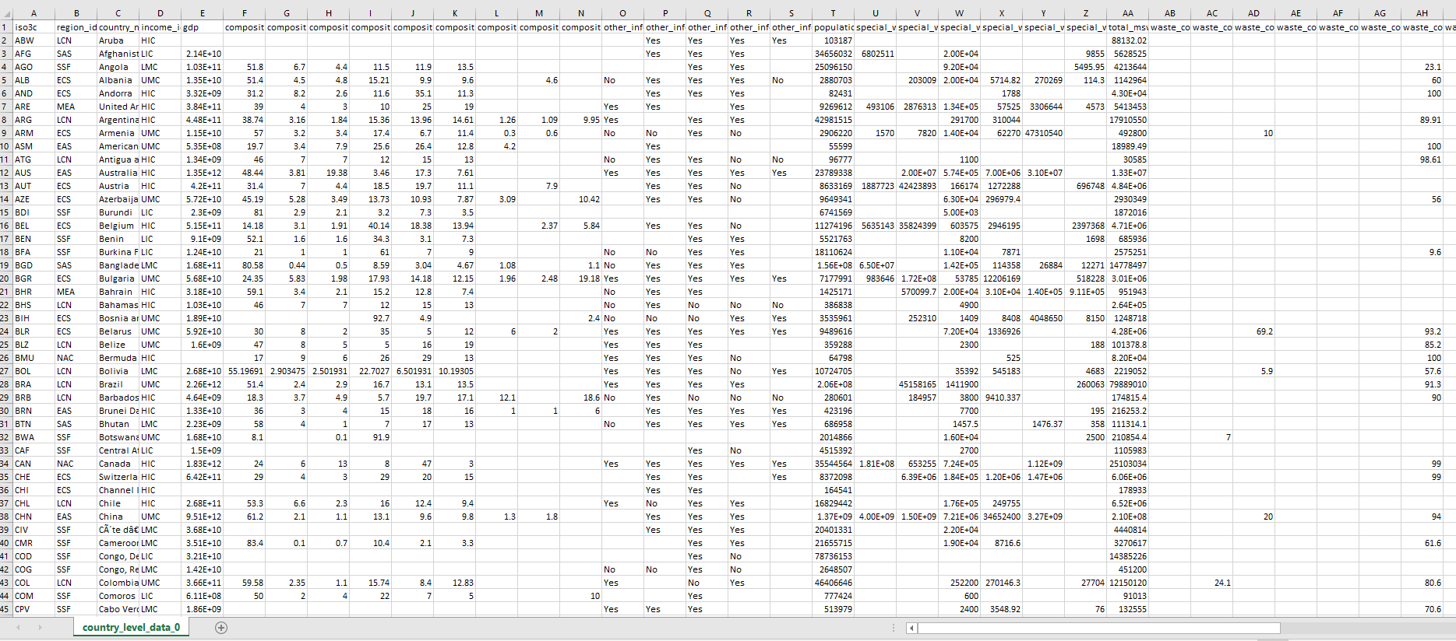

Figure : Dataset before Processing

## 2.2 Data Processing (Progress)

Using Python, the data was read from the CSV file into a Pandas data frame. The columns being used for the visualisations were selected and we then created a copy of the data frame where rows with no GDP were removed and another where the rows with no total municipal solid waste were removed. This was done because there seemed to be no method to do the removal in one step. These two new data frames were then combined, and any duplicates removed. This final data frame was then exported to a csv file without the index, as the index was not needed for the visualisation.

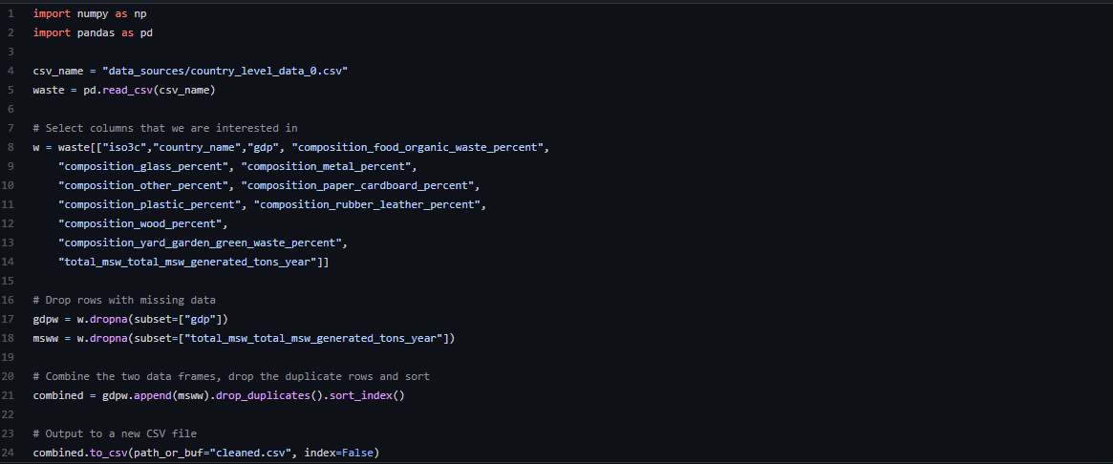

Figure : Program for Data Processing

## 2.2 Data Processing (Final)

Prior to processing there were 51 columns. After processing the data, we had 13 columns which were relevant to producing the visualisations. There were only 2 rows removed while processing: the rows for Sint Marteen (Dutch Part) and Turks & Caicos Islands had no relevant data for the visualisations.

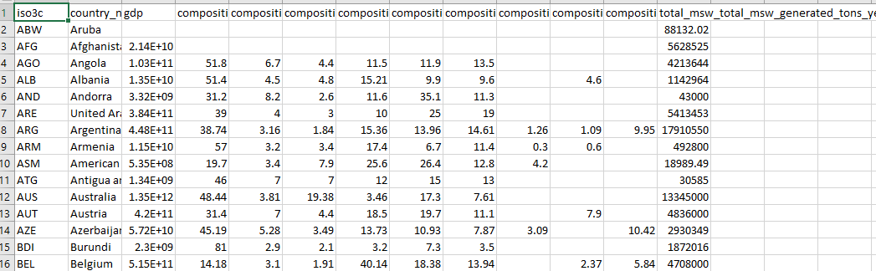

Figure : Processed Data

# **3.Requirements**

There are two different types of requirements for the project: a set of must-have features and a set of optional features. The must-have features are things that need to be implemented for the project to be successful. Optional features are features that are not essential for the project but would improve the experience for end users.

## 3.1 Must-Have features (Proposal)

Below are the essential features which were proposed during the design phase.

* Choropleth map visualisation: total solid waste produced by countries.
* Scatter plot visualisation: GDP and total solid waste.
* Pie charts: composition of waste for each country with this data.
* Tool tips and mouse over highlighting
* Interactivity between Choropleth and Pie Chart

## 3.1 Must-Have Features (Final)

Below are the features which play a vital role in making the website successful. There were some new features in addition to the ones proposed.

* Choropleth map visualisation: total solid waste produced by countries.

For the Choropleth map, we decided to show the total MSW (in tonnes) produced by each country. The user can understand the data (amount of waste) for a particular country by looking at the map.

* Scatter plot visualisation: GDP and total solid waste.

For the scatter plot, we have decided to compare GDP and total MSW (in tonnes) produced by each country.

* Pie charts: composition of waste for each country with this data.

The pie chart shows the composition of waste produced by each country. Each section shows the percentage of waste produced for each category by the selected country.

* Tool tips and mouse over highlighting

Tooltips show more details about the item that the cursor is over. They allow the user to get the actual value rather than the value range (for the choropleth map), or an estimate according to the axes (for the scatter plot).

* Interactivity between Choropleth and Pie Chart

Displaying a pie chart for each country would either take up a large amount of space or mean each chart is extremely small and illegible. We have, therefore, decided to allow the user to click on a country in the choropleth map and then render a pie chart for that country.

* Panning and zooming for map and scatterplot

The choropleth map and scatter plot display many data points at once and the user may find this overwhelming. In addition, there was a substantial number of overlapping data points in the scatter plot. To alleviate this, we decided to implement a way for the user to zoom and pan both the choropleth map and scatter plot. This way the user can more easily view the part of the visualisation they are interested in.

* Legends to show what colours represent in charts.

A legend is an essential feature of many visualisations. A user may be expected to know that a darker colour on a choropleth map corresponds to a higher value from their experience with other similar visualisations. However, they would not be able to determine what range of values a particular shade represents. Similarly, they may recognise that the different hues used in the pie chart represent different categories of waste, but they would not know which category each hue corresponded to. Adding a legend ensures that the user can more easily understand the data.

3.2 Optional Features (Proposal)

These are some optional features which were proposed at the beginning of the design phase. These are not the essential features but may improve the user experience of our visualisation.

* Way to swap between visualisations.
* Way to resize visualisations.
* Way to filter which countries appear in scatter plot.

3.2 Optional Features (Final)

Below are the finalized optional features which were implemented on the website. These features make the website user friendly.

* Way to swap between visualisations.

User is provided with buttons which help them in changing the required visualisations as required. They can easily swap between visualisations.

* Way to resize visualisations.

Users may find that our visualisations are rendered at an inappropriate size for their device. We could implement a way for the user to change the size that the visualisation is rendered at to meet their requirements more closely.

* Way to filter which countries appear in scatter plot.

Users may wish to only view some subset of countries that are shown in our visualisation. For example, they may wish to compare their own country to other countries that have a similar economic status or geographical region. To allow for this, we could implement a way to filter which data points are shown in the scatter plot.

* Close button provided for Pie Chart

Users are provided with a close button which closes the Pie chart once it is prompted. This helps users in efficiently completing their goals.

## 3.3 Successfully Implemented features

All must-have features were successfully implemented. The only optional feature that was able to be implemented was being able to swap between visualisations, due to time constraints.

# **4. Visualisation Design**

## 4.1 Initial designs

Once the data had been collected, appropriate marks and channels had to be chosen to represent the data. Care needed to be taken to ensure that the visualisations could have sufficient data density while not misrepresenting the data or overloading the user. A variety of sketches were created to test different combinations of marks and channels. After appropriate marks and channels had been chosen, higher fidelity prototypes were created before starting the implementation of the visualisation.

Initially, a bar chart to display the data was considered. This was rejected as there was too much data to display at one time. Some options to alleviate this issue were discussed, such as adding a method to filter and sort the data that was being displayed. However, it was decided that a choropleth map would be more appropriate. It was assumed that users would be familiar with a world map and would find it simple to interpret the data.

Another alternative that was considered was to create a stacked bar chart to display both the total solid waste produced by countries as well as the composition of the waste in one chart. This would have the same drawbacks as the bar chart above and therefore was not selected. Instead, a separate chart was created to show the composition of waste for each country. For this purpose, a pie chart was chosen, as this was assumed to be a familiar way to present data relating to proportions to users. The pie chart was linked to the choropleth map by allowing the user to click on a country to display the waste composition.

We drafted paper prototypes for our different visualisations. These prototypes allowed us to identify different features that will help the user to interpret the data. We also identified any drawbacks of the proposed design. At this stage, we were not able to identify all benefits and drawbacks of our design.

For completeness, we also drafted a sample bar chart.

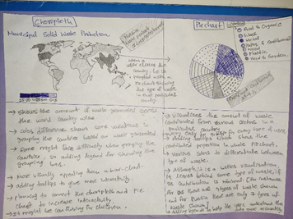

Figure : Sketches for Choropleth and Pie Chart

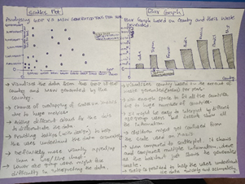

Figure : Sketches for Scatter Plot and Bar Chart

## 4.2 High-fidelity prototyping

Once low fidelity prototypes had been created and it was decided which visualisations we would be producing, we created higher fidelity prototypes using tools available on the Internet. These higher fidelity prototypes allowed us to have a better understanding of how our finalised visualisations would appear and to plan for any additional functionality that would improve the user experience. For example, by creating these prototypes we could determine that it would be useful to allow users to zoom and pan the data on the scatter plot, since it was difficult to interpret the data at lower values of GDP and MSW generated. Examples of the high-fidelity prototypes can be seen in the following sections.

## 4.3 Choropleth map progress

In our early prototypes, we intended to implement a horizontal legend showing approximate values for each different hue. We later changed this to give more precise values for each hue used in the visualisation. We also determined that zooming and panning would be a useful feature for the choropleth map, due to the relatively small size of many countries.

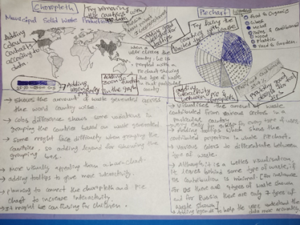

Figure : Required changes in the design and features (Choropleth and pie Chart)

Below is the high-fidelity prototype for the choropleth map. It shows our intended design including tooltips. We later decided to change the design for our tooltips.

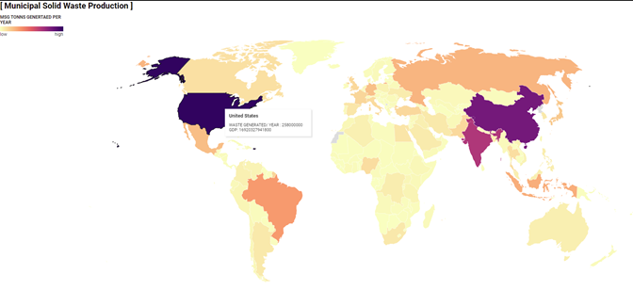

Figure : High Fidelity Prototype for Choropleth

Following the high-fidelity prototype, we implemented the basic functionality for our choropleth map. This version did not have the correct colors used for the different values, as when we read the data in using D3, we did not convert the data to the appropriate types. This was fixed in the next iteration. This version also did not implement the zooming and panning functionality or the legend. When creating the visualisation we had several countries with no data. We opted to render these countries in a color that was not part of the color scheme for countries with data.

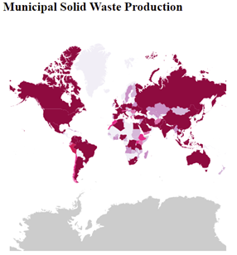

Figure : Progress of Choropleth

We later decided to change the color scheme of the choropleth map and added the legend. This was our final design for the choropleth map and included all functionality including zooming and panning, and tooltips.

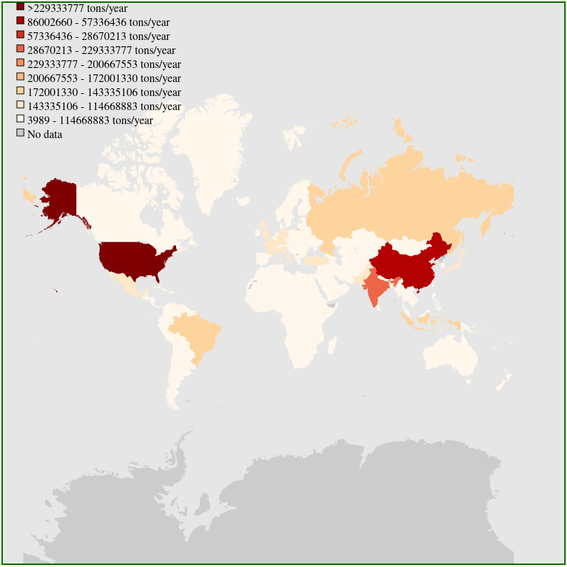

Figure : Final design of Choropleth

## 4.4 Pie Chart Progress

The pie chart started with a paper prototype showing the main features that we wanted to implement in our visualisation. We decided to link the pie chart and choropleth map together by allowing the user to click on a country to open the corresponding pie chart. This means that we are not rendering many charts at one time, which could be overwhelming for the user. We also added tooltips and a legend to improve the user’s experience with our visualisation.



Figure : Required changes in the design and features (Choropleth and Pie Chart)

We then created a high-fidelity prototype to reference while creating our visualisation. This prototype showed the main features that we hoped to implement in our final visualisation.

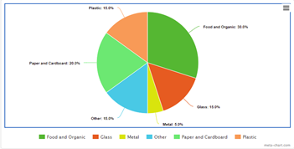

Figure : High fidelity Prototype for Pie Chart

We began implementing the pie chart visualisation. This was our initial design and it contained most major features we had planned, except for the legend. We later decided to remove the values being shown on each slice and instead these were only kept in the tooltips.

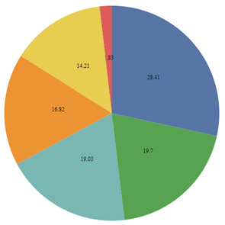

Figure : Progress of Pie Chart

Finally, we added a legend and tooltips to the pie chart, and this was our final design.

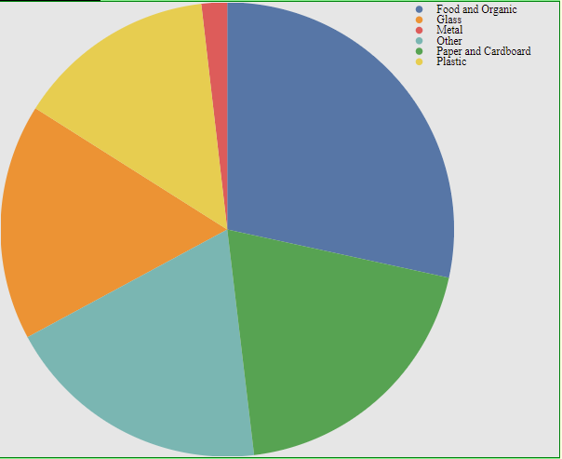

Figure : Final design of Pie Chart

## 4.5 Scatter Plot Progress

While creating the prototypes for the scatter plot we identified several issues that could cause issues for the user. Most countries were clustered in the lower values of GDP and MSW produced with very few countries with high GDP and MSW generated. This made it difficult to understand the data. To alleviate this, we decided to implement zooming and panning of the visualisation.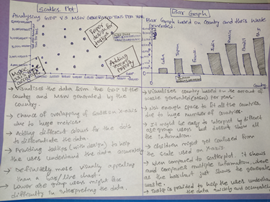

Figure : Required Changes in design and features (Pie Chart)

We produced a high-fidelity prototype of the scatter plot using a small subset of values from our data set. From this prototype we were able to determine the issues that would be faced while implementing the visualisation.

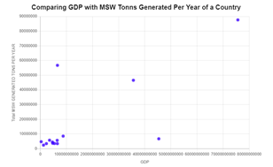

Figure : High Fidelity prototype for Scatter Plot

While implementing the scatter plot, we faced several issues. Due to the issue with reading data into D3 incorrectly, the scales were not defined correctly. Once we converted the data into the correct types, our scales and axes correctly represented the data. The values shown on the axes were overlapping on the x-axis, while the y-axis values were off the side of the visualisation.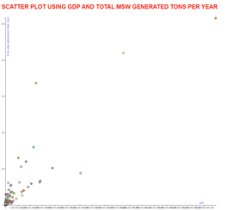

Figure : Progress of Scatter Plot

We were able to fix the axes and implement panning and zooming to create our final design.

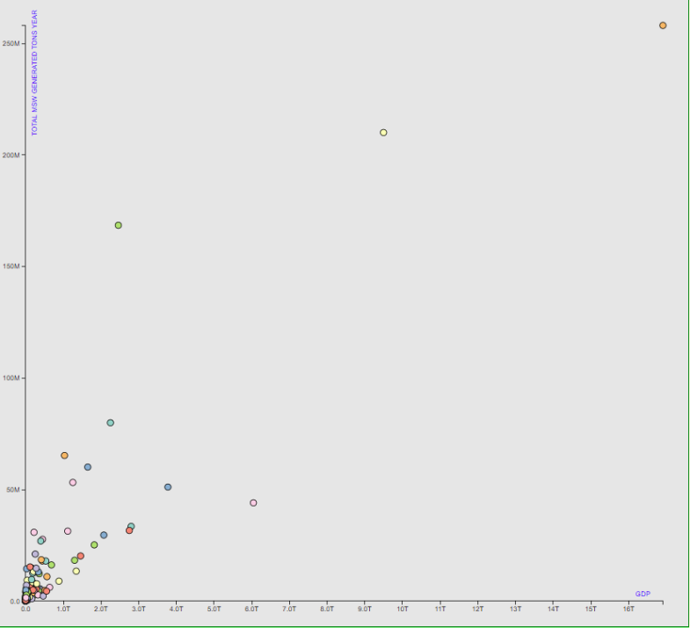

Figure : Final design of Scatter Plot

## 4.5 Finalising the Design

Once we had successfully implemented all features in our visualisations, we could combine them all into a single page. We were able to implement one optional feature, allowing users to swap between the choropleth map and scatter plot. We then applied appropriate CSS to ensure that our visualisations were appealing for the user.

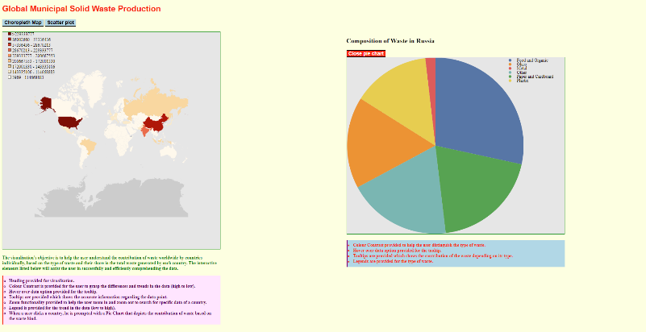

Figure : finalized design of website ( Choropleth and Pie Chart)

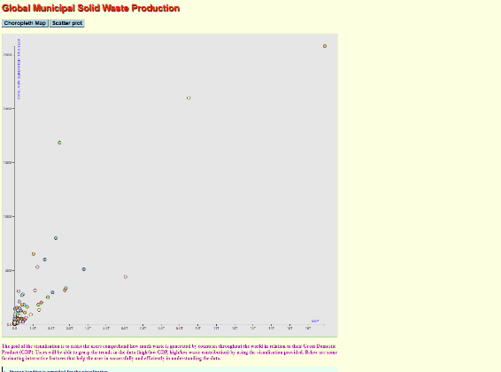

Figure : Finalized design of website (Scatter Plot)

# **5.Validation**

Conducting an evaluation of the created website using the primary users (main user), aids in the gathering of ideas for contemporary design challenges, provides description of a user’s problems faced while using the website and frequently proposes extra website resources that will improve the user experience for all user group. It encourages us in reflecting on user’s requirements and experience. Conducting a user-based evaluation is a best practice to evaluate the work.

We have used google forms to conduct user evaluation. Google forms gives you huge number of features in creating different type of questions and saves the responses for each form created.

## 5.1 Informed Consent

This is a Usability Evaluation explanatory statement; it gives a detailed explanation of the process involved in evaluation, individual roles involved, and some user declaration statements which help in making the evaluation successful. It is the first document given to the user before we start any kind of evaluation. This usually contains rules and regulations, some personal information required to be filled by the user.

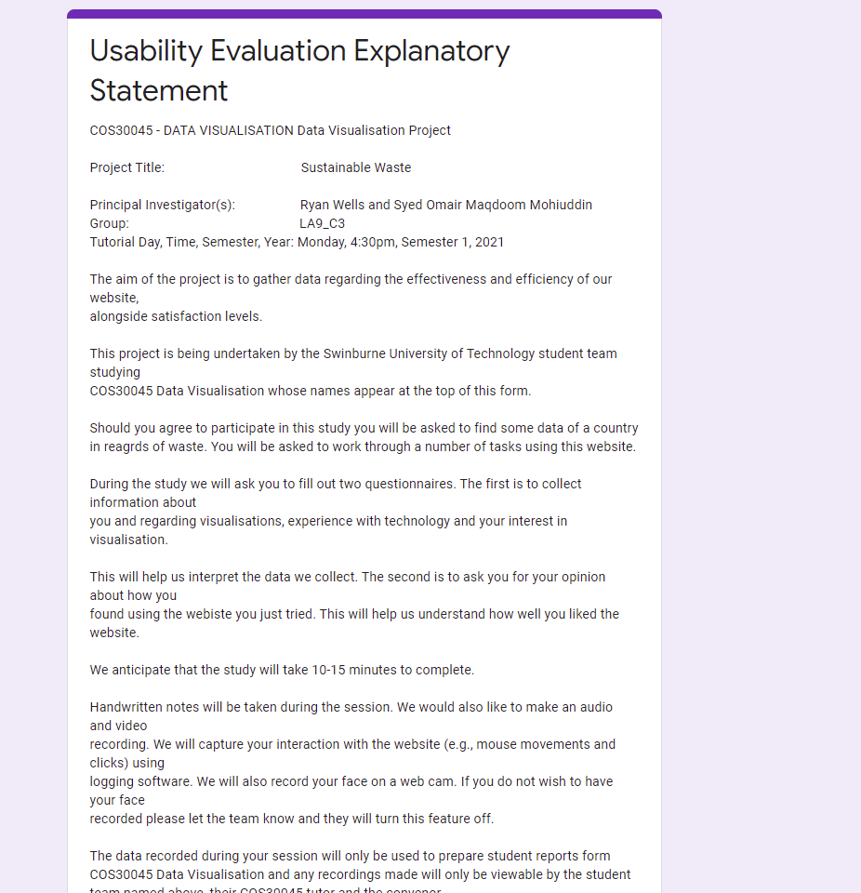

Figure : Explanatory Statement for User Evaluation

## 5.2 Pre-Study Questionnaire

This is next step following the explanatory statement, it usually relaxes the user by asking some usual questions regarding their daily life which are indirectly connected with the project. It helps the user prepare for the evaluation. Questions regarding their age, frequency using websites to gather information, using any kind of visualisations, frequency using visualisation and other which help us determine the user behaviour (for instance, user group).

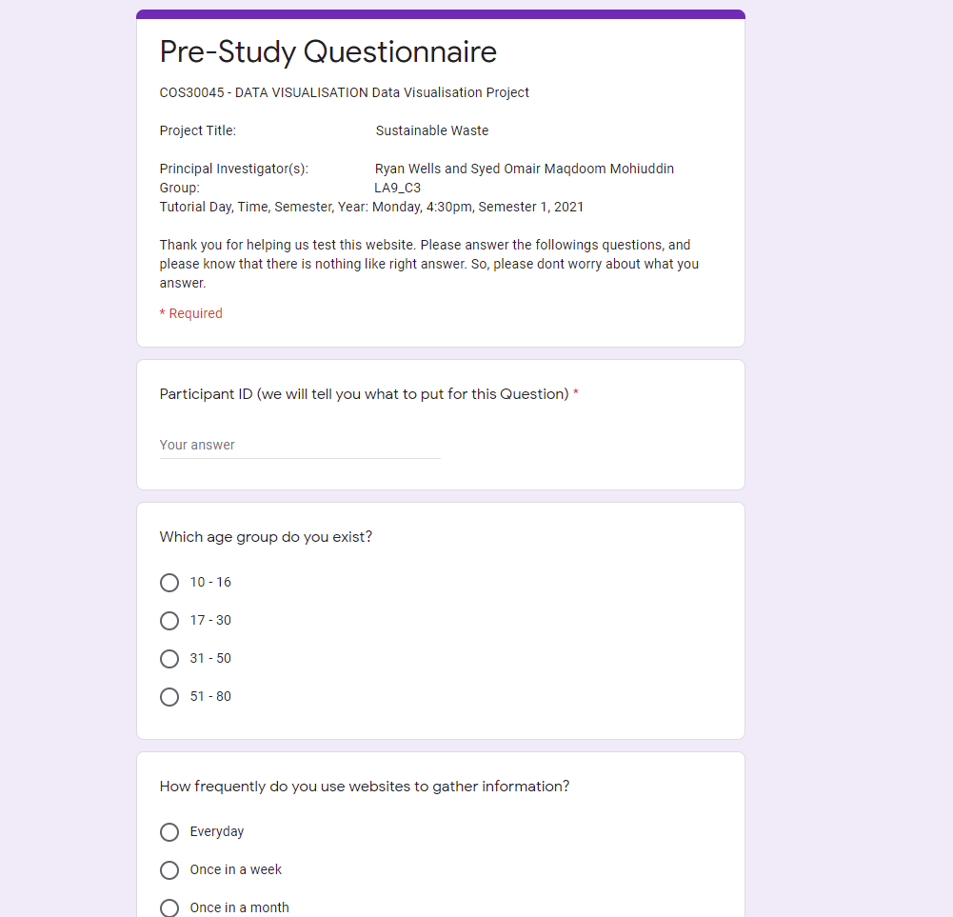

Figure : Pre-Study Questionnaire

## 5.3 Evaluation Tasks

This is an essential phase in the evaluation process, we are required to note the user expressions, behaviour, and confidence. They are presented with some questions which are related to the website, using the link provided which takes them to the website, they are required to answer the questions. Parallelly, we record the time taken to answer each question, reaction towards each question, and confidence while answering the question.

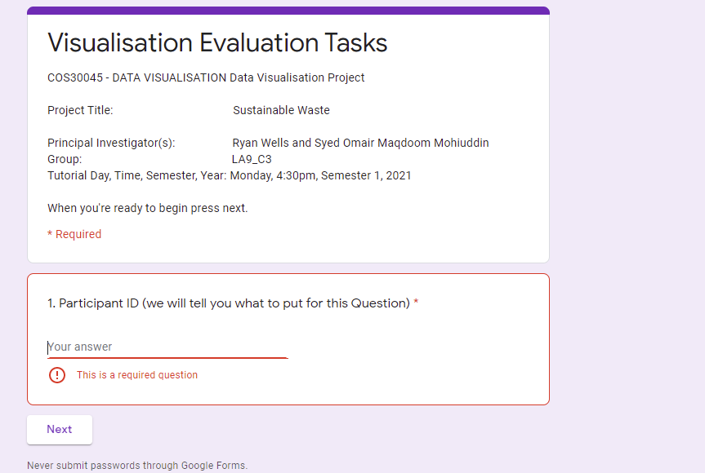

Figure : Validation

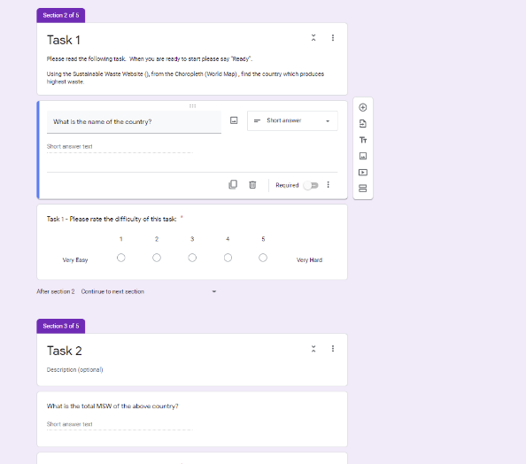

Figure : Given tasks in Evaluation

## 5.4 Post-Study Questionnaire – 1

Once the participants successfully completed the evaluation tasks and answered the questions, we conduct a post study questionnaire which contains questions regarding the feedback of website. Some questions like least choice (for instance, background colour) on the website, missing features as per their thinking, suggested improvements and other regarding the website.

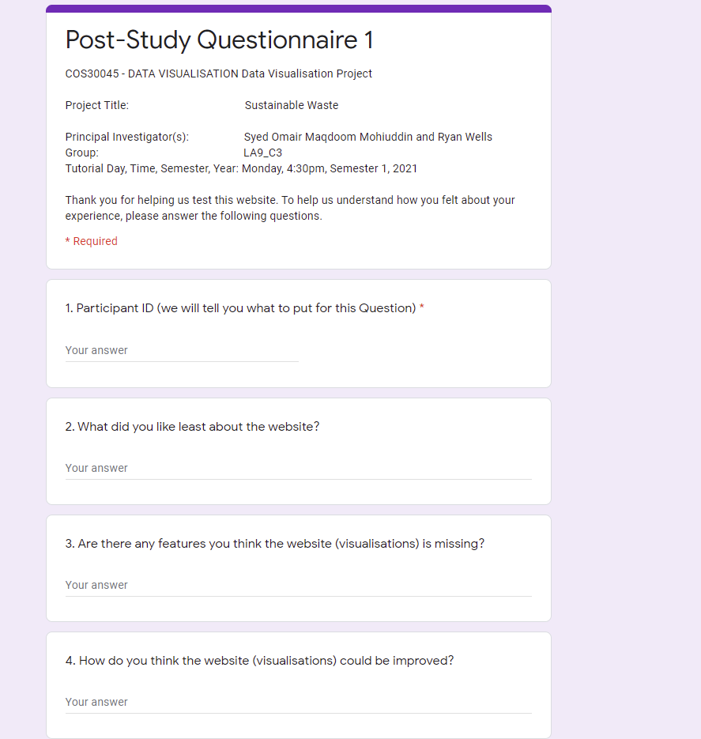

Figure : Post Study Questionnaire -1

## 5.5 Post-Study Questionnaire – 2

This the continuation of the post study, it helps understanding user’s internal thinking regarding the use of website. Questions asked on based on their experience using the website and feedback on website. This helps us to decide either to update any features or add/remove some features.

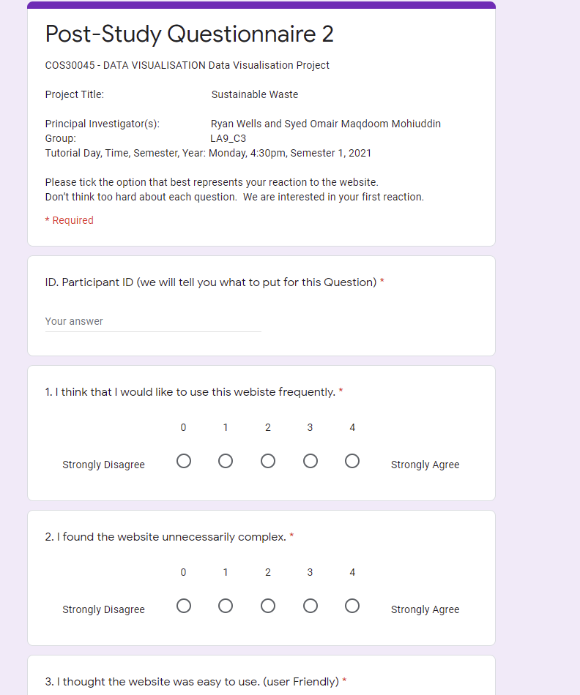

Figure : Post Study Questionnaire - 2

## 5.6 Responses and Results

Reporting the responses from users and analysing them for gathering the information. If there are any catastrophic problems on the website, then we can change or update the website, else any minor changes can be left or changed based on its criticality.

### 5.6.1 User Observation

Observing and noting user’s behaviour helps in understanding the user’s mental thinking and keeps track of the accuracy and effectiveness of completing a task. We should not help/disturb them while doing a task, if they ask any help then we need to just explain the task to some extent, because these are the best practices that should be followed when conducting user evaluation.

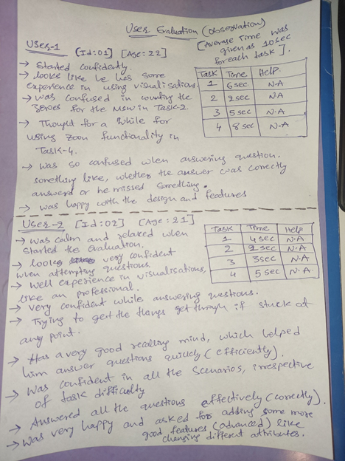

Figure : Notes recorded during User Evaluation

#### 5.6.1.1 User – 1

User was confident when evaluation started. Looking at his confidence, he might have prior experience in using visualisations. Successfully completed Task-1, was quick in recalling the hover-over feature and got back for the answer but was confused in counting the zeroes for the MSW in Task-2. Successfully answered Task-3, with confidence. When started Task-4, was a bit confused using zoom functionality. While answering the question, has a suspecting feeling whether the answer is correct. Although was not confidence but was successful in completing the task. User was happy with the design and features of the website. Below table shows the usability metrics(efficiency) for User-2.

Table : Usability Metrics for User-1

|  |  |  |
| --- | --- | --- |
| Task | Time | Help |
| 1 | 6 Seconds | N.A |
| 2 | 2 Seconds | N.A |
| 3 | 5 Seconds | N.A |
| 4 | 8 Seconds | N.A |

#### 5.6.1.2 User – 2

User was calm and relaxed when started the evaluation. Was very confident when attempting questions. Has a very good recalling mind, which helped him answer questions efficiently. Was confident in all scenarios irrespective of task difficulty. If stuck at any point, was trying to get the things going. Answered all the question effectively. Respective user was pleased with the design and was willing to see new features like adding buttons for changing the data attributes. Below table shows the usability metrics(efficiency) for User-2.

Table : Usability Metrics for User-2

|  |  |  |
| --- | --- | --- |
| Task | Time | Help |
| 1 | 4 Seconds | N.A |
| 2 | 2 Seconds | N.A |
| 3 | 3 Seconds | N.A |
| 4 | 5 Seconds | N.A |

5.6.2 Responses

Google forms saves the response for each individual user. We can analyse the results and determine the required updates using these responses.

Below are the responses of the Usability Evaluation Explanatory Statement. Responses were recorded for each individual user.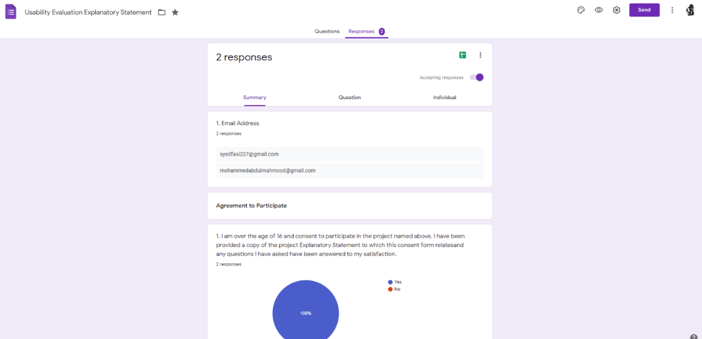

Figure : Responses recorded from Explanatory Statement

Below are the responses of Pre-Study Questionnaire. Each individual user has their own view and attempting questions. We can observe that various users have various cognition.

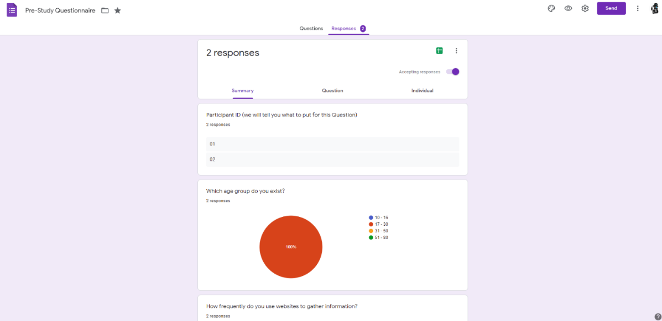

Figure : responses recorded from Pre Study Questionnaire

Below are the results of Evaluation task. These responses play vital roles in determining the usability metrics (efficiency and effectiveness). We have observed that both the users were successful in attempting and answering all the questions effectively and efficiently. Using the usability metrics, we determine the frequency, impact and persistence of the identified error and required recommendations will be discussed and a best solution for these errors will be finalized.

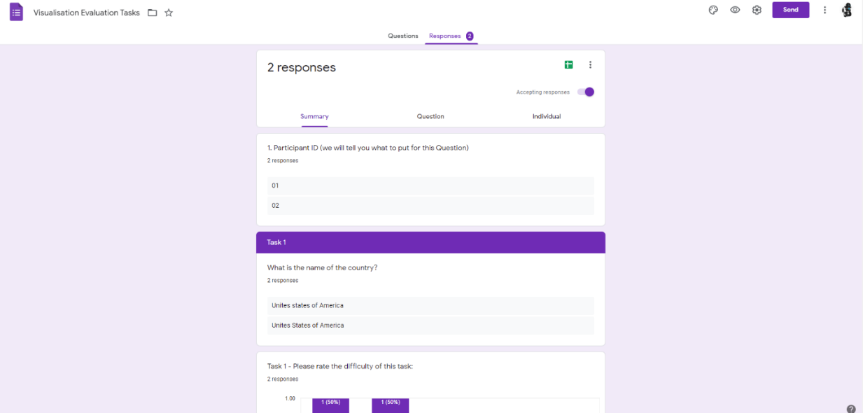

Figure : Responses recorded from evaluation

Below are the responses from the Post Study Questionnaire –1. These responses help us understand what users think regarding the website. It provides us with suggestions and feedback about the functionality and design of the website.

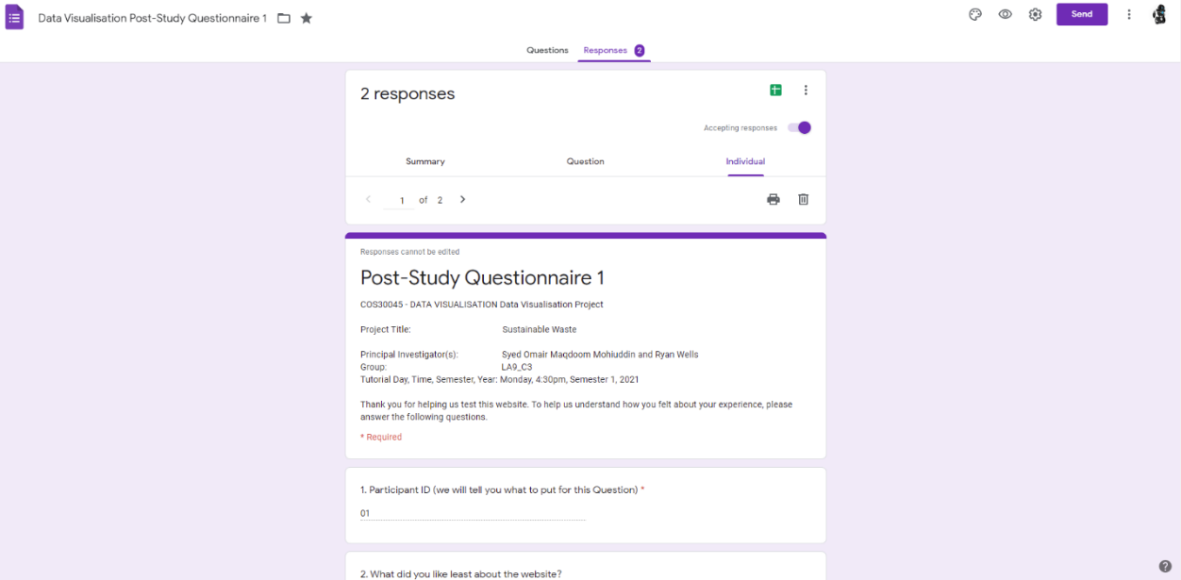

Figure : Responses recorded from Post Study Questionnaire -1

Below are the responses gathered from Post Study Questionnaire –2. We used these responses and determined the satisfaction of the users by using the website.

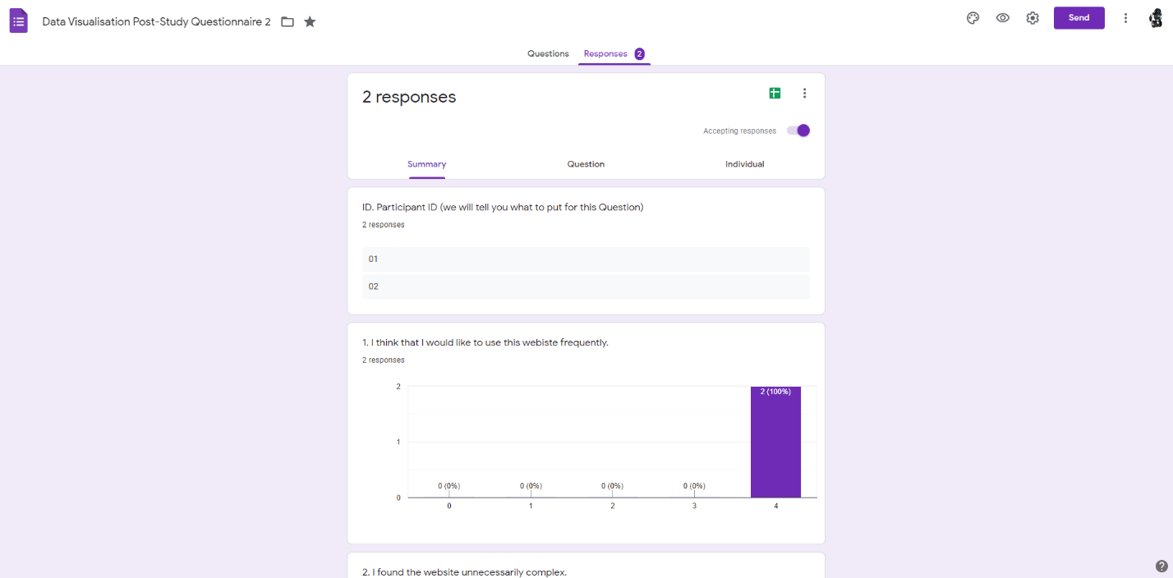

Figure : Responses recorded from Post Study Questionnaire - 2

**Comparison with Targets**

Table : Comparing the Targets

|  |  |  |  |
| --- | --- | --- | --- |
| Tasks | Effectiveness Target | Efficiency Target | Satisfaction target |
| Task 1 | 100% | 10 sec | 2/2 |
| Task 2 | 100% | 10 sec | 2/2 |
| Task 3 | 100% | 10 sec | 2/2 |
| Task 4 | 100% | 15 sec | 2/2 |

## 5.7 Required Changes

Using the responses, feedback, and usability metrics from the user evaluation, we discuss the updates required in design and functionality of the website. Although, there were no catastrophic risk recorded, there were minimal risks on the website which can be updated or left. Because these are the common errors which become barries for the users while using the website. Below are recommended features that can be implemented.

* Adding zoom in and zoom out buttons in the visualisation (affordance), which gives hint that there is zoom functionality in the visualisations.

Due to time constraints proposed features were not implemented.

# **6. Conclusion**

While completing this project we followed an iterative design process to produce a variety of visualisations using a data set that would be encountered in the real world. We faced some difficulty with creating our visualisations, such as our data not displaying correctly, but were able to solve these issues and create a finished product. Through conducting a user evaluation, we were able to receive feedback on how to improve our visualisations and although we were not able to implement the changes during this project, we have a better understanding of how users will interact with our visualisations and how to create better visualisations in the future.

# **References**

Jason F, Michael B, 2020, Gross Domestic Product (GDP), viewed: 11 June 2021

< https://www.investopedia.com/terms/g/gdp.asp>

Munzner, T 2014, *Visualization Analysis and Design*, CRC Press LLC, Florida. Available from: ProQuest Ebook Central. [20 May 2021].

The Paper, (2015), *Design Principles: Alignment,* viewed: 12 June 2021

< https://blog.thepapermillstore.com/design-principles-alignment/ >

The World Bank (2018). *What a Waste Global Database,* Viewed: 8 March 2021.Retrieved from <https://datacatalog.worldbank.org/dataset/what-waste-global-database>

UX Collective, 2020, *Principles of Design: the application of contrast and similarity,* Viewed: 10 June 2021

< https://uxdesign.cc/principles-of-design-the-application-of-contrast-and-similarity-d87f261fb84f>

UX Planet, 2018, *UX Design Glossary: How to Use Affordance in User Interfaces*, viewed: 12 June 2021

< https://uxplanet.org/ux-design-glossary-how-to-use-affordances-in-user-interfaces-393c8e9686e4>

Virginia R, 2018, *What is a Prototype? viewed: 5 June 2021*

*< https://medium.com/nyc-design/what-is-a-prototype-924ff9400cfd>*

Vonbaggo,K 2021, I*NTRODUCTION TO DATA VISUALISATION PART 1, Data Visualisation*, Learning material via canvas, Swinburne University of Technology, 2 March. [10 May 2021]

1. These codes are listed at https://unstats.un.org/unsd/tradekb/Knowledgebase/Country-Code